Joshua Harris  Lead Pastor  Covenant Life Church  Gaithersburg | 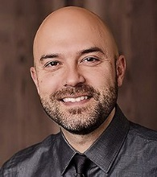 | Bobby Little  Director  Christian Embassy  Washington DC | 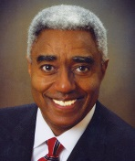
Gregg Harris  Director  Noble Institute  Gresham OR | 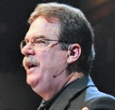 | Eric Teetsel  Director  Manhattan Declaration Washington DC
Darrin Patrick  Founding Pastor,  The Journey Church  St. Louis, MO | 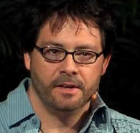 | Hugh Whelchel  Dir. Institute for Faith, Work & Economics  McLean VA
Tom Joyce  Former Top Gun pilot; 9/11 Pentagon survivor and his son Justin, wounded warrior |  | George Lawson  Sr. Pastor  Baltimore Bible Church Baltimore MD
Mark Mitchell  Executive Pastor  Covenant Life Church  Gaithersburg | 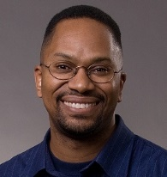 | Jack Merenda  Pastor  Care & Counseling  Immanuel Bible  Springfield VA | 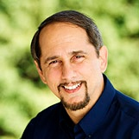
Jason Ellerbrook  Director, Men’s Programs LifeWay  Nashville TN | 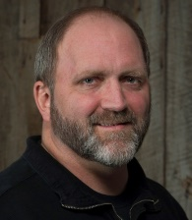 | Mike Minter  Teaching Pastor  Reston Bible  Dulles VA | 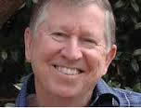
Jesse Johnson  Teaching Pastor  Immanuel Bible  Springfield VA | 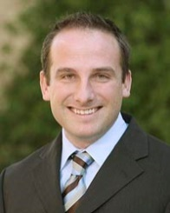 | Steve Reynolds  Sr. Pastor  Capital Bible Church  Annandale VA | 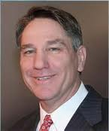
Rex Tignor  Training Director  WACMM  Glen Allen VA | 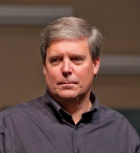 | Pete Alwinson  Vice President  Key Life Network  Orlando FL | 